Hakko revenge
Soldering station user manual and instructions

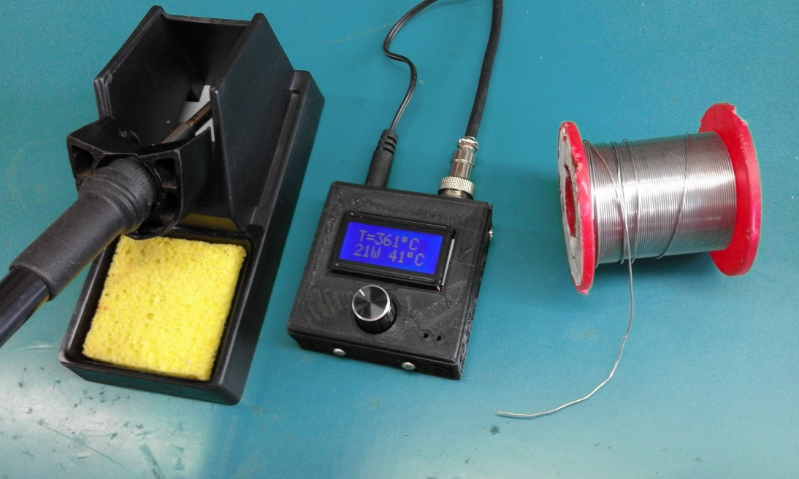

Contents
Introduction 3
Abbreviations 3
Component parts 3
Absolute maximum ratings 5
Technical characteristics 5
Features 5
Chart of errors 6
Internal diagram 7
Aviator plug connection diagram 8
Tip structure 8
Settings and display explanation 9
Menu map 10

Introduction
The Hakko revenge soldering station is a reliable product that was designed be a good universal soldering tool for all the types of electronic components on the market. It can solder everything from the tiny sot23 SMD components up to the largest thru hole terminals and wire lugs. Speed of reaction, precision, long lasting life, configurability, good human interface and low power consumption are only a few key features of this product.

Abbreviations
MCU | Microcontroller Unit
t12 | Tip type
ROM | Permanent flash memory with electronic erase
RAM | Random Access memory
HW | Hardware
SW | Software
SMD | Surface mount device
LCD | Liquid crystal display
Min | Minimum
Max | Maximum
Typ | Typical
PCB | Printed Circuit Board
Ovr | Over
Err | Error
HSD | High side driver

Component parts

- Input power adapter connector
- Aviator plug for connecting the tip handle
- Case screws
- Case
- Rotary encoder knob
- LCD display
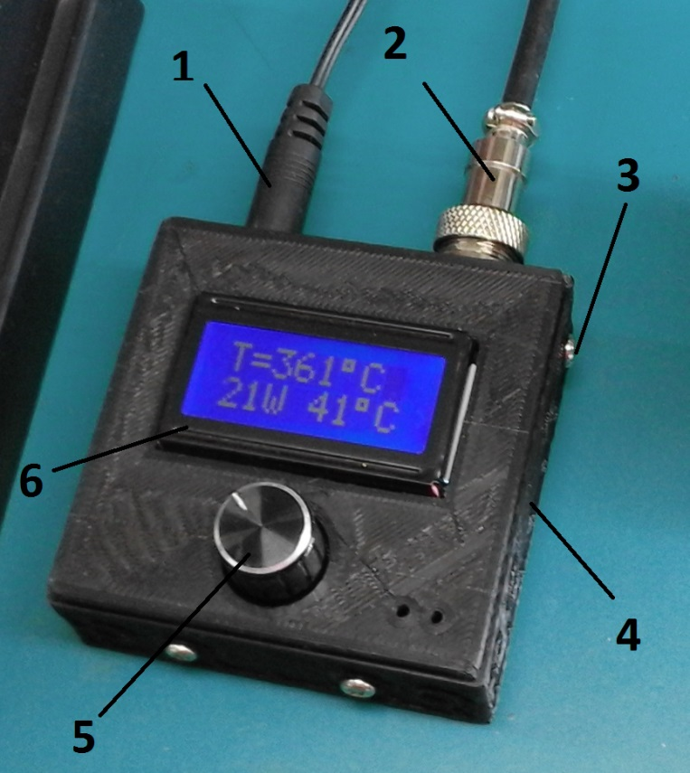

Absolute maximum ratings

 | Min | Typ | Max | Unit | Comment
Absolute voltage limits | 6 |  | 35 | V | Will not work or be damaged outside of this limits
Maximum absorbed current |  |  | 3.5 | A | At 35V
Storage temperature | 5 |  | 50 | ⁰C
Storage humidity | 20 |  | 85 | %RH
Working temperature limits | -10 |  | 65 | ⁰C
PCB maximum temperature |  |  | 85 | ⁰C | Displayed on the screen

Technical characteristics

 | Min | Typ | Max | Unit | Comment
Input voltage | 12 | 24 | 29.5 | V
Input current |  |  | 3.5 | A
Tip type | t12
Tip resistance |  | 10 |  | Ω
Operating environment temperature | 5 | 25 | 50 | ⁰C

Features

- Precise temperature t12 soldering station tip with low thermal inertia and inbuilt thermocouple
- Easy to use and set
- Ability to set the actual temperature of the tip between 70⁰C and 430⁰C
- Ability to set a standby temperature between 70⁰C and the soldering temperature
- Thermal shut down (see the Over temperature error in the Chart of errors section)
- Other error warnings (see the error chart)
- Reverse polarity protection for 5 to 10 seconds depending on the reverse voltage value
- Ability to set the time before entering stand by between 1min and 6min and 30sec
- Long lasting tip life because of the Stand by feature
- Overall low power consumption achieved by the stand by feature
- LCD screen with alphanumeric chars and backlight
- Small, compact, comfortable and ergonomic design
- Sound warnings and audio signals
- Internal menu that can display the tip temperature, the PCB temperature, the tip status diagnose, the voltage and the power dissipated on the tip

Chart of errors

Error message  displayed on the screen | Description | Comment
Ovr temp | Over temperature | PCB over temperature set from firmware at 85⁰C initiates thermal shut down
Ovr volt | Over voltage | Over voltage error set at 29.5V. Exceeding this input voltage will trigger this error
Err plug | Error with the aviator plug, the wiring or plug is being disconnected | When the aviator plug is being disconnected, or a wire is loose inside the soldering tip handle
Err tip | Tip error or heating element internal damage | Is being activated when the heating element inside the t12 tip is drawing too less or too much current. These limits are set to 0.5A, respectively 5A. In normal voltage operating conditions, these limit values should never occur. If this error shows up, and the voltage is within the ranges, this means that the internal resistance of the heating element is changing due to aging. It is either short circuiting or interrupting because of long functionality. If everything else is OK, change the tip.
Errors | Multiple errors | If two or more of the above stated errors are present, this message will be displayed.

Internal diagram
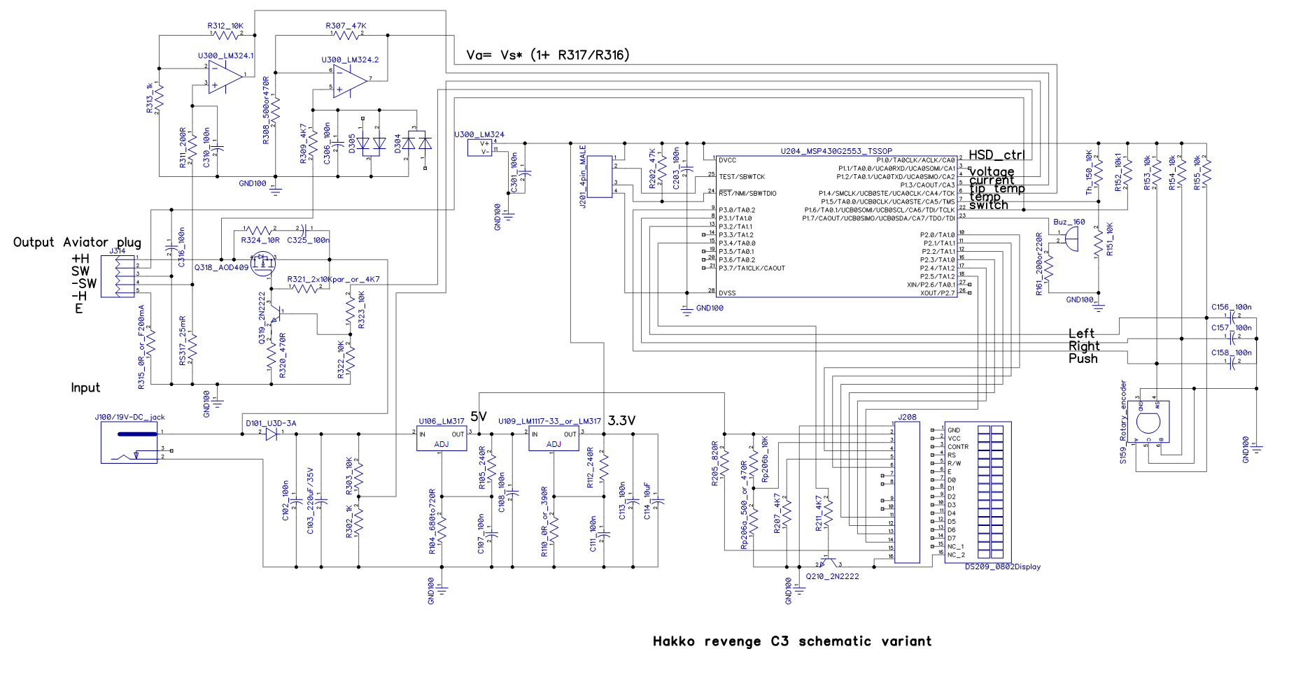

Aviator plug connection diagram
The aviator plug is a 5 pin GX12 type.

Tip structure
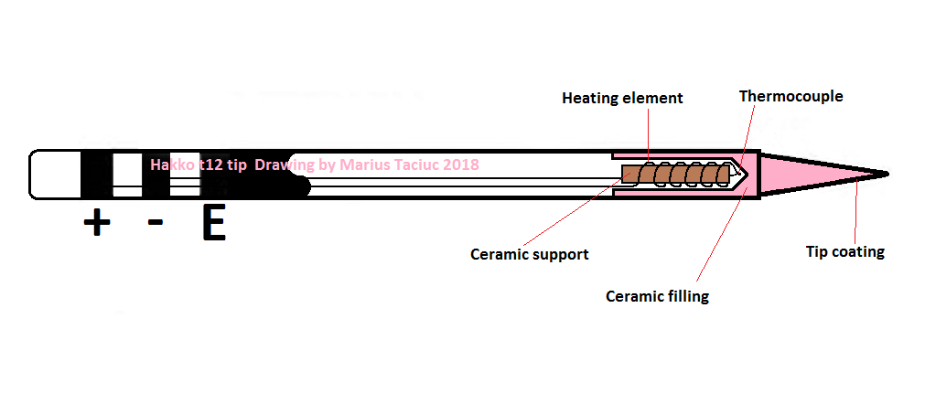

Settings and display explanation
The solder menu
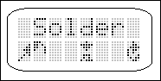
When the hakko revenge soldering station powers up it displays this screen. The symbols of the screen are showing you that you can either rotate the rotary encoder knob to navigate to the right menu or press the knob to enter this main soldering function of the device.
Once inside this soldering menu, you will see the following information being displayed:
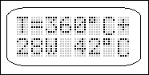
The first row displays the temperature tip. After entering this menu, this first line will show the target temperature for approximately 2 seconds. Then it will begin to show the actual temperature of the tip. The “+” symbol in the top right corner comes up when the tip is being powered. The second line shows the tip dissipated temperature in watts and the temperature of the PCB. During operation, this second line can display some errors or diagnostic messages like shown in the Chart of errors section.

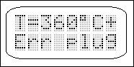

To navigate away from this menu, press the rotary encoder once for one second. A return to main menu (symbolized with “Main”) and a return to the Solder menu option (symbolized with “Back”) will be displayed on the screen. By selecting the Main option the user can return to the main menu and start navigate to all the other menus from there.

The UP temp menu
This menu gives the user the possibility to set the working temperature or the actual soldering temperature. This temperature can be set between 70 and 430⁰C

The Low temp menu
This menu gives the possibility of setting the stand by temperature to which the tip will drop after a certain period of time of inactivity. This stand by temperature can be set between 70⁰C and the soldering temperature. For instance, if the working temperature is set to 390⁰C, the user won’t be able to set the stand by temperature higher than this. The best recommendation for this setting would be around 190⁰C just above the melting point of a regular 60/40 tin alloy solder. This will prolong the tip life and it also prevents the leftover tin on the tip to burn up and oxidize. This ensures maximum adhesion next time the user starts to solder.

Time hot menu
This menu sets the time of inactivity before the tip temperature will drop to the stand by temperature. This time can be set between 1minute and 6 minutes and 30 seconds. Every time the user moves the handle, an internal switch activates inside and resets the counter inside the MCU.

Sound menu
Many display features and warnings are followed by audio signalling. These signals might vary in intensity and frequency. To change these sound settings, the user must first press the knob to enter this menu and then select between the options from 0 to 5. Option 0 means mute.

The Info menu
Displays a series of data just for the user’s information as:
- The firmware version. For example, SW-V3.1 means firmware version 3.1
- The PCB and hardware version. HW-V3.2 means HW variant C2. The first number before the decimal point (in this case 3) corresponds to the letter version A, B, or C
- The input voltage.
- The PCB temperature
- The tip temperature
These datas and measurements can be checked at power up before starting to use the soldering station.

The Default menu
This menu will reset all the settings to default when accessed. All the settings will also be stored into the permanent ROM memory of the MCU and they will be able to be accessed after power down or restart.

Menu map
